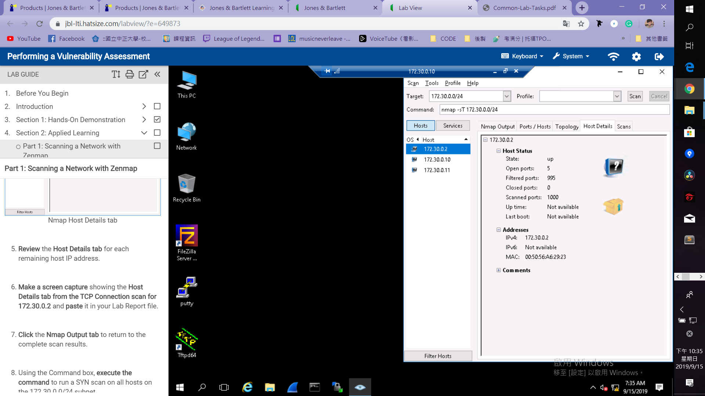

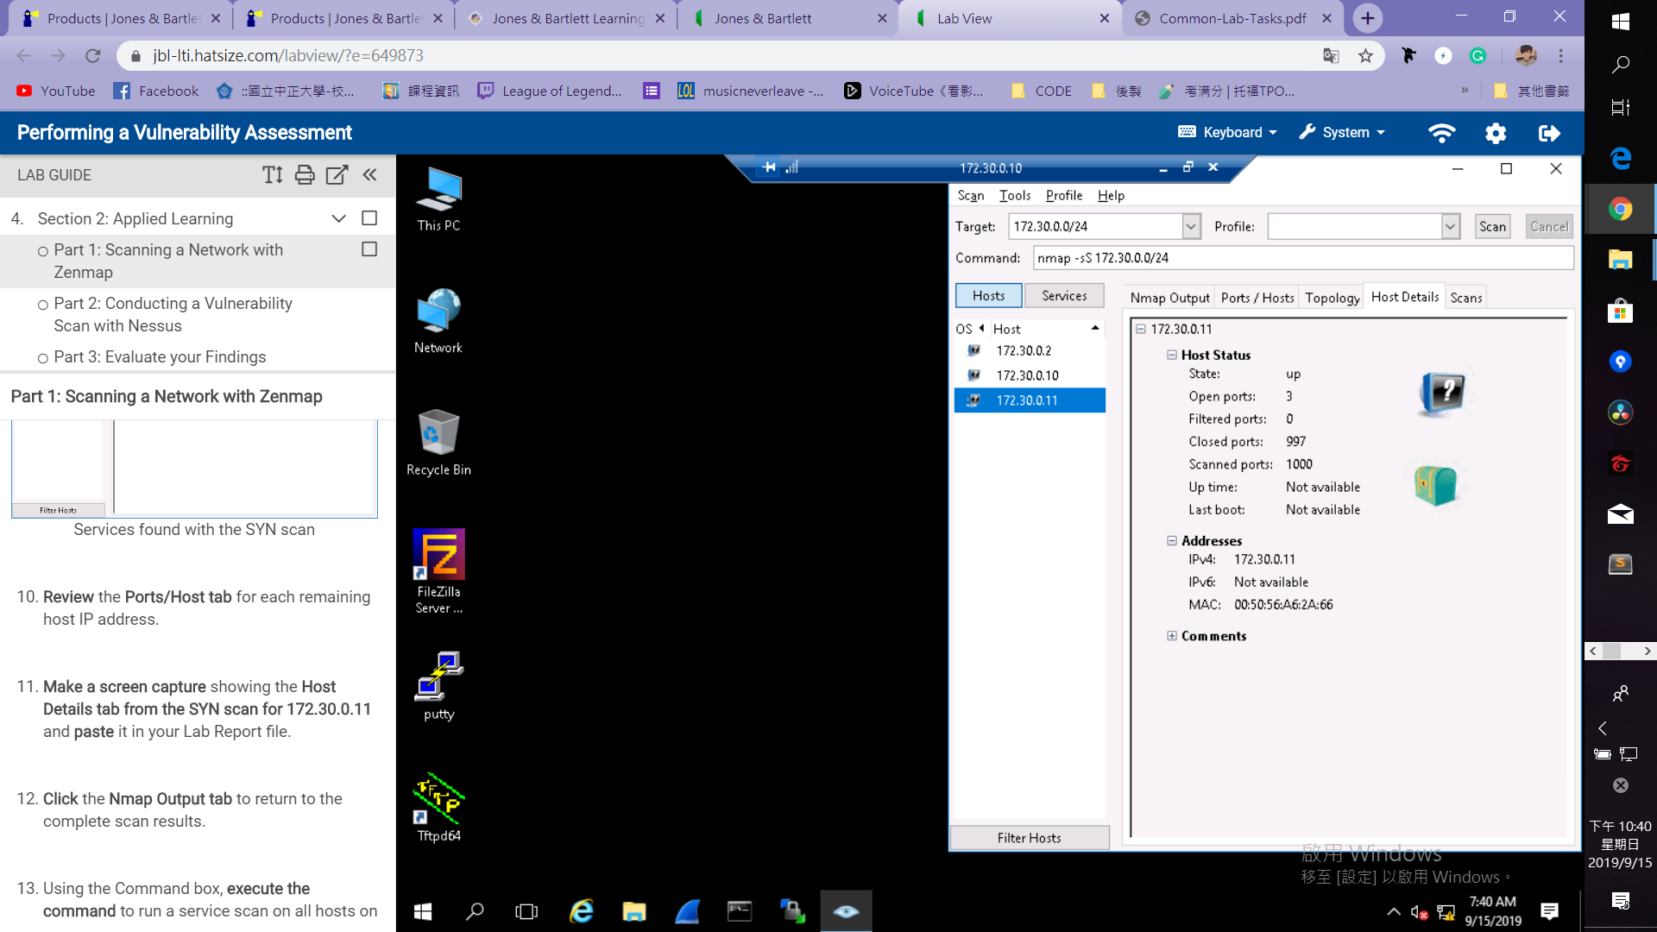 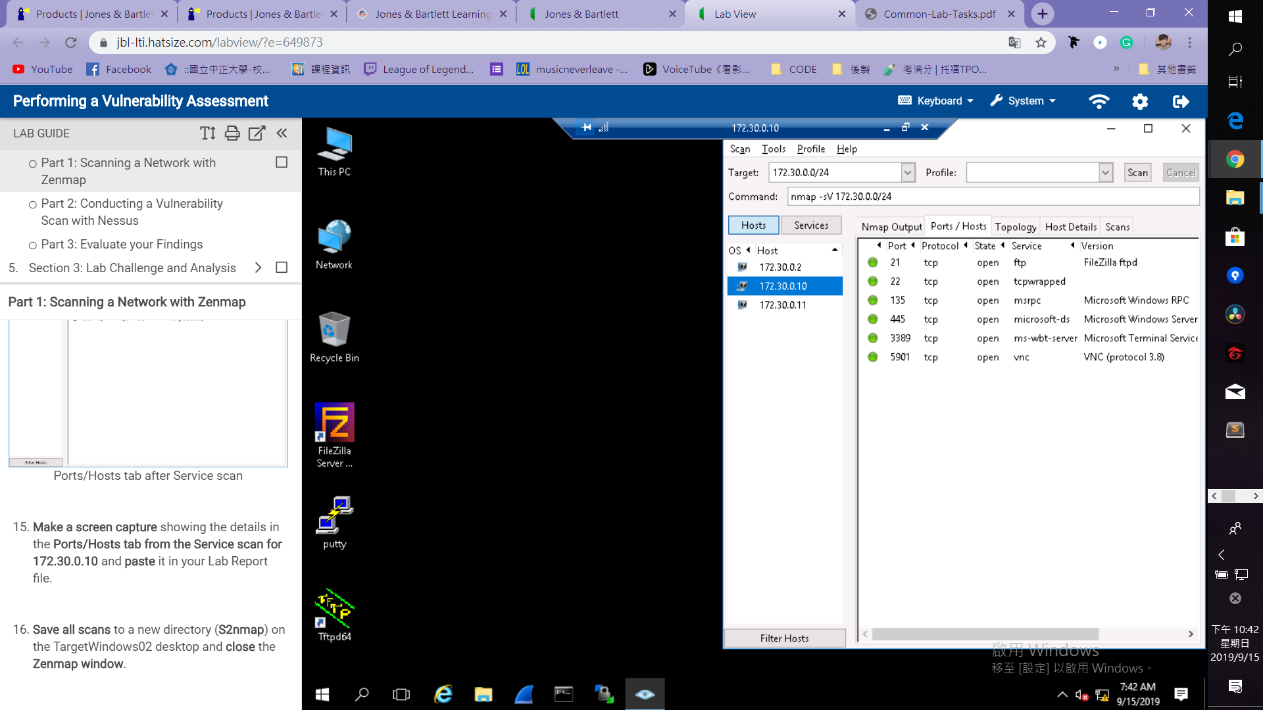

**Medium-risk vulnerabilities found on 172.30.0.11**

Medium (4.3) 58453 Terminal Services Doesn't Use Network Level Authentication (NLA) Only.

Recommendations: On Windows, System > Remote > Enable Network Level Authentication (NLA).

Medium (4.3) 90317 SSH Weak Algorithms Supported.

Recommendations: remove the Arcfour ciphers and weak ciphers.